## Exercise 5: Temperature Converter

Write a function that takes one parameter - a float which represents a temperature in Celsius - and returns a float which represents that temperature in Fahrenheit.

Then, write a function that does the opposite conversion.

Here are the formulas for temperature conversion:

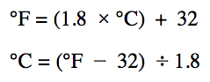

Finally, write some code below your functions that

uses them to convert 0 degrees Celsius and 100 degrees

Celsius to Fahrenheit, and to convert 40 degrees

Fahrenheit and 80 degrees Fahrenheit to Celsius.

Make sure to print your results for the above

to the console.